Note-

1. The Subnet in which we are creating Application gateway that will only contains application gateway, no other resources.
2. Version – v2 version allow additional features such as zone redundancy, autoscaling, firewall custom rules (WAF)
3. Make sure to enable draining facility

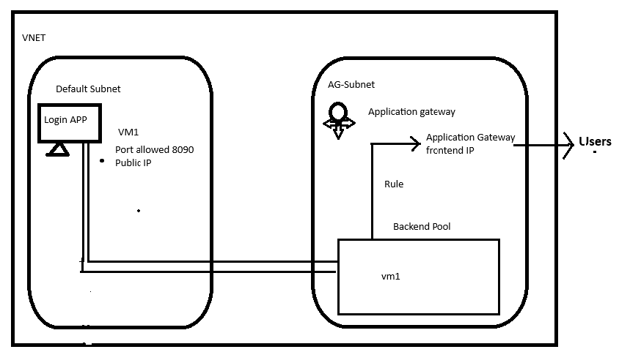

Can we enable zone redundancy by changing version (standard v2)  
  
\* we can choose Existing public ip as frontend ip for the application gateway from any vnet and subnet.

We can not delete public ip from application gateway directly without assigning another ip to it.

Note- Application gateway does not allow to add multiple ip to frontend listener.  
  
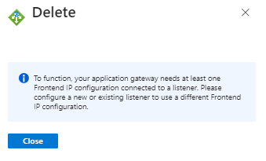

How many listener we are adding it will be added under same public ip

So logically it’s not possible to move front-ip from one application gateway to another with out decommissioning existing.

If we delete Application gateway ip associated with it does not get deleted automatically.

We can add multiple application gateways to 1 firewall policy rule.